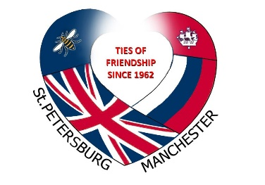
Manchester St Petersburg Friendship Society
Membership Renewal/Application Form
Please complete this form and return with the appropriate fee to the Treasurer:
Jim Charnock, 27 Bollin Drive, Timperley, Altrincham, WA14 5QR
Name
Address
Postcode
Tel
Mobile
Email
Signature
Date
Payment type (delete as appropriate) | Cheque/Bank transfer

Type of member | Individual | Associate* | Institution
Fee | £10 | £5 | £15
Tick as appropriate
The above are annual subscription rates. If you wish, you can send a cheque for £45 for a five-year membership. Please note this is optional.
Cheques should be made payable to Manchester St Petersburg Friendship Society or payment can be made by bank transfer to Sort Code: 01-05-11 Account: 05940575, giving your name as a reference.
* Associate members are persons living in the household of a full member, accepting the Society’s aims and not requiring separate mailings, OAPs, under-18s, full-time students and registered unemployed.
Extract from the Constitution: The aims of the Society shall be non-party and non-sectarian:
- To work for the continued friendship and greater understanding between the citizens of St Petersburg and its region and those of Greater Manchester

- To maintain and develop friendly relations, which will help cultural exchanges and promote trade to the mutual benefit and satisfaction of both cities

- To exchange factual information about St Petersburg region and Greater Manchester

- To facilitate interest in Russia, its people and its culture

